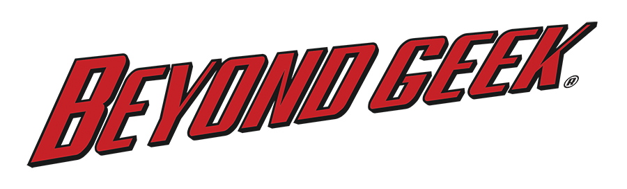
Beyond Geek

Beyond Geek airs on public television and PBS stations across the nation.

Show Descriptions

Long Description: Beyond Geek is a television series about people who take geek to the next level. From a group trying to get to space in a balloon, to people who dress up as superheroes to fight crime, in each episode you’ll experience a fascinating new world full of people pushing the limits of science, technology, and everything geek.

Short Description: Beyond Geek is a television series about people who take geek to the next level.

Episode Descriptions

Season 1 Episodes

Episode 101

Title: Junk Car Racing

Description: Nate joins the ultimate endurance race with 500-dollar cars where anyone can be a race car driver.

Episode 102

Title: Battle Games

Description: The Medieval era meets Middle Earth in full-contact combat that has Sage engaging in a battle that would make Tolkien proud.

Episode 103

Title: 8-Bit of Fun

Description: Dan learns how to breathe new life into outdated computers by transforming them into musical instruments with a sound that’s both new and old.

Episode 104

Title: Floating to Space

Description: Nate reaches for the final frontier with a group who has spent the past 30 years trying to get to space in a balloon.

Episode 105

Title: WW2 Re-enactors

Description: History comes alive as Dan gets a glimpse of what it was like to serve in World War II by donning a uniform and going to battle for the Allies.

Episode 106

Title: Real Superheroes

Description: Sage joins a group of people who dress up as superheroes to fight crime and finds out there’s more to them than just the tights.

Season 2 Episodes

Episode 201

Title: Kinetic Sculpture Racing Part 1

Description: Dan races against all odds in a human-powered art sculpture race over land, sand, and water.

Episode 202

Title: Kinetic Sculpture Racing Part 2

Description: With everything going wrong, will Dan and the Hot Roddenberrys even finish the race?

Episode 203

Title: The Force is Strong

Description: Brittni wields the ultimate sci-fi weapon in lightsaber combat.

Episode 204

Title: Hackathon

Description: Nate races against the clock on a team creating something out of thin air in a 44-hour hackathon… and tries to do it with no sleep.

Episode 205

Title: A Pirate’s Life for Me

Description: Nate travels through time into a world filled with black powder weapons, sword fights, and adventure.

Episode 206

Title: High Flying Smackdown!

Description: Brittni learns to settle the score on the mat as she enters the world of pro-wrestling.

Episode 207

Title: Telerobotics

Description: Dan discovers how robots can open up your world to endless possibilities.

Episode 208

Title: Beam Me Up

Description: Brittni beams aboard a Star Trek fan film to help them create their latest production.

# # #

