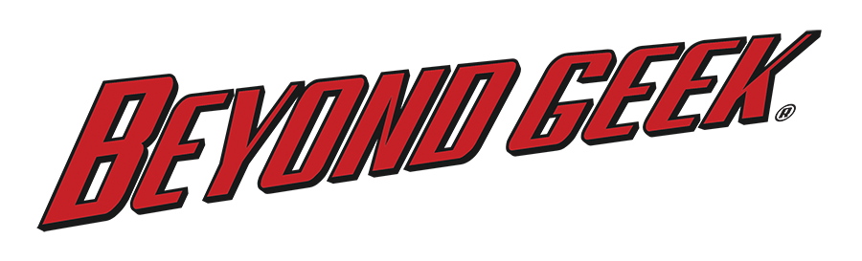
Meet the Hosts of Beyond Geek
Brittni Barger, Beyond Geek Host
Brittni Barger studied Theatre and Dance at New York University's Tisch Hall and California State University, Sacramento. She is a member of Actors Equity and a Company Member of California's prestigious B Street Theatre. Brittni has also appeared in productions on other prolific Sacramento stages such as Capital Stage and Sacramento Theatre Company. On YouTube she has had regular appearances on Smosh, a channel that has acquired 20 million subscribers and 4.2 billion views. She is also a writer, producer, and performer on the Four Letter Nerds channel, geeking out primarily on bibliophilia. Brittni’s infectious energy and enthusiasm along with her ability to instantly click with others make her a great fit for hosting Beyond Geek.
Nate Lake, Beyond Geek Host
Nate’s entertainment career began in 1995 as a contestant on The Price is Right. A natural performer from class-clown to television personality, his appearance on more than one game show led to a life-long hobby of candid film ranging from pranks to unofficial interviews and hidden-camera montage. Nate’s eye for beauty and style is manifested in his street-fashion collective, Domanate Clothing, and he is a partner with Joe Simpson at SLS Advertising Company. Nate’s enthusiastic personality and innate ability to connect with all kinds of people—and have them and us laughing in no time—are what make him a great host on Beyond Geek.
Sage Michael, Beyond Geek Host
Having vowed to truly experience the most that life has to offer, Sage has helped orphans in Malaysia, worked as a bounty hunter, served honorably in the Gulf War, hand-delivered food, toys, and medical supplies to villages in Mexico, donated over a thousand children’s books to start a library in Africa, handed out thousands of pounds of food to the homeless, and tried his hand at shark diving, rock climbing, paragliding, and skydiving. Sage is the author of How to Become a Super Hero: The Ultimate Guide to the Ultimate You—a book in which he teaches people to have the most fulfilling life they can possibly have. Sage’s love of people and his desire to jump right in to whatever adventure comes his way bring excitement and fun to his episodes of Beyond Geek.
Dan Reynoso, Beyond Geek Host
As an elementary school teacher of 20+ years, Dan has incorporated his passion for life into his teaching style and makes his classroom a world of wonder for his students. As a punk rock musician, he has toured the world playing drums for The Secretions and The Groovie Ghoulies, playing guitar for The Moans, The Knockoffs, and Kepi The Band, and has ventured on solo tours with just a suitcase and an acoustic guitar. As a masked Mexican wrestler (whose identity is a super secret), he has wrestled all over the West Coast and shared a ring with legends such as The Raging Bull Manny Fernandez, Bison Smith, The Honky Tonk Man, and Mustafa Saed, and he helped train former WWE Superstar, John Morrison. And now, Dan brings his wit, humor, and imagination to a new platform as a Host of Beyond Geek.

Behind the Scenes at Beyond Geek
Joe Gillis, Beyond Geek Creator and Executive Producer
Joe brings his prime-time experience as Producer, Writer, and Editor on HGTV and DIY Network shows including Turf War, Yard Crashers, House Crashers, Bath Crashers, and Room Crashers, as well as his public broadcasting experience on America’s Heartland and California’s Heartland. For Joe, before television there was film: Joe produced a feature-length film Voices from the High School, adapted from a play by Peter Dee and which now sells to learning institutions across the nation, and a short silent film entitled 9 Items or Less which shows hilarity ensuing in a crowded shopping market. A lifelong technology/comic book/science geek, it was only a matter of time before Joe was to combine his working knowledge of television production with his true passion, the fascinating world of all things geek: Enter Beyond Geek!
Rachel Gillis, Beyond Geek Executive Producer
Rachel has been a geek her whole life. As a kid, her idea of fun was doing logic puzzles, winning spelling bees, or taking tests. In college she majored in microbiology, minored in chemistry, and had (and still has) a special love for parasites. And now as an adult, she’s addicted to coding projects in computer science programming classes that she takes “for fun.” Rachel’s undeniably true identity as a geek makes her a great fit for Beyond Geek.
David Limutau, Beyond Geek Composer
David grew up listening to everything from soul and jazz to country and classical. To him, good music was not limited to any particular genre. This love of music led David to become a self-taught musician, and fed his desire to create music for a living. In 2010 he joined Los Angeles based production team the Finisherz, working with such artists as E-40, David Faustino, Mike Jones, and more. Finding a niche in the growing industry of podcasting, he created music for popular shows including The Fringe Podcast, The Revolution Podcast, and The Almost Human Podcast. David’s ability to create such a wide range of music makes him the perfect fit for a television show as diverse and distinct as Beyond Geek.

# # #

